*Unfortunately, due to a lack of computing power, we were not able to answer the questions of the ‘third end product’ for the entire dataset. In order to still give an answer, we therefore took a sample of 1.000 entries from the patstat table and answered the questions for this sample.*

a)

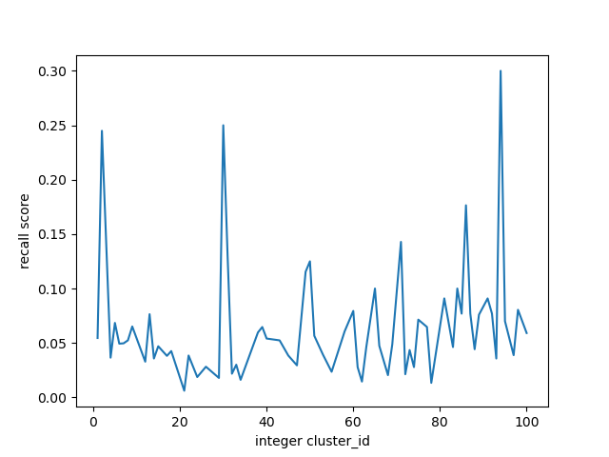

b)

|  |  |
| --- | --- |
| Average precision | 0.84 |
| Average f1 | 0.11 |
| Average recall | 0.06 |

c)

A cluster with really good (the best so far actually) is cluster 94 with an f1_measure of 0.46

A cluster with really poor (the worst so far actually) is cluster 21 with an f1_measure of 0.01

The table score_cluster contains all the data on precision, f1 and recall for all the clusters